Insert your name, centre number and candidate number into the header above.
Save this evidence document as evidence_ followed by your centre number_ candidate number. For example: evidence_ zz999_9999.doc
Screenshots or program listings must be copied into appropriate cells in the following tables.
Examiners must be able to read the contents including any screenshots without the use of a magnifying glass. Answers that are not readable or missing will not be awarded any marks.
Save this evidence document at regular intervals, for example, every 10 minutes.
Question 1
Part 1(a)
{Copy and paste program code listing for question 1(a) here}

def ReadWords(FileName):
global WordArray
global NumberWords
fr=open(FileName, 'r')

x=fr.readline().strip()

while x!="":
WordArray.append(x)
NumberWords+=1
x=fr.readline().strip()
NumberWords-=1
fr.close()

#main
WordArray=[]
NumberWords=0

Part 1(b)
{Copy and paste program code listing for question 1(b) here}

#main
WordArray=[]
NumberWords=0

Level=input("Choose one of the difficulty among 'easy', 'medium' and 'hard'. ").lower()
if Level=="easy": ReadWords("Easy.txt")
elif Level=="medium": ReadWords("Medium.txt")
elif Level=="hard": ReadWords("Hard.txt")

Part 1(c)(i)
{Copy and paste program code listing for question 1(c)(i) here}

def Play():
global WordArray
global NumberWords

print(f"Main word: {WordArray[0]}\nNumber of answers: {NumberWords}")
CorrectAns=0
Exit=False
while not Exit:
InputWord=input("Enter a word, or enter 'no' to exit. ").lower()
if InputWord=="no":
Exit=True
else:
for j in range(1,len(WordArray)):
if WordArray[j]==InputWord:
print(f"Your answer: {InputWord} is an correct answer.")
CorrectAns+=1
WordArray[j]=None
break

Part 1(c)(ii)
{Copy and paste program code listing for question 1(c)(ii) here}

def Play():
global WordArray
global NumberWords

print(f"Main word: {WordArray[0]}\nNumber of answers: {NumberWords}")
CorrectAns=0
Exit=False
while not Exit:
InputWord=input("Enter a word, or enter 'no' to exit. ").lower()
if InputWord=="no":
Exit=True
print(f"You entered {(CorrectAns/NumberWords)*100}% of answers.")
print("Here's the remaining answers.")
for j in range(1,len(WordArray)):
if WordArray[j] is not None:
print(WordArray[j])
else:
Correct=False
for j in range(1,len(WordArray)):
if WordArray[j]==InputWord:
print(f"Your answer: [{InputWord}] is a CORRECT answer.")
Correct=True
CorrectAns+=1
WordArray[j]=None
break
if not Correct:
print(f"Your answer: [{InputWord}] is an INCORRECT answer.")

Part 1(d)(i)
{Copy and paste program code listing for question 1(d)(i) here}

def ReadWords(FileName):
global WordArray
global NumberWords
fr=open(FileName, 'r')

x=fr.readline().strip()

while x!="":
WordArray.append(x)
NumberWords+=1
x=fr.readline().strip()
NumberWords-=1
fr.close()
Play()

Part 1(d)(ii)
{Copy and paste screenshot for question 1(d)(ii) here}

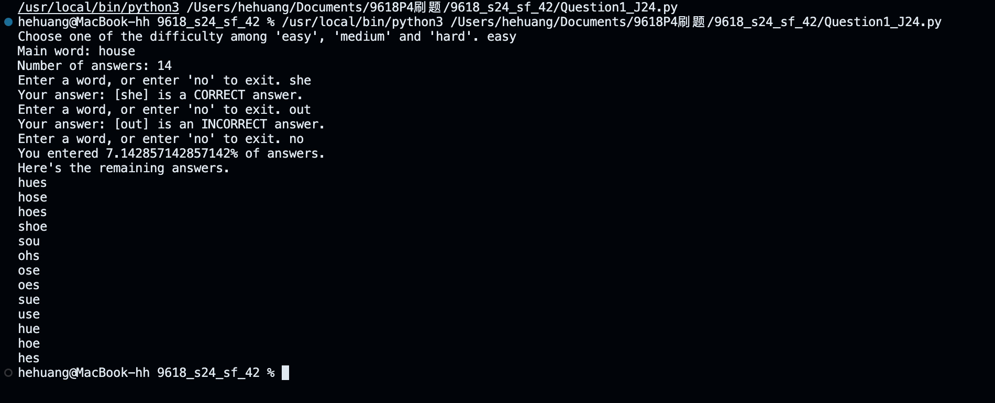

Part 1(d)(iii)
{Copy and paste screenshot for question 1(d)(iii) here}

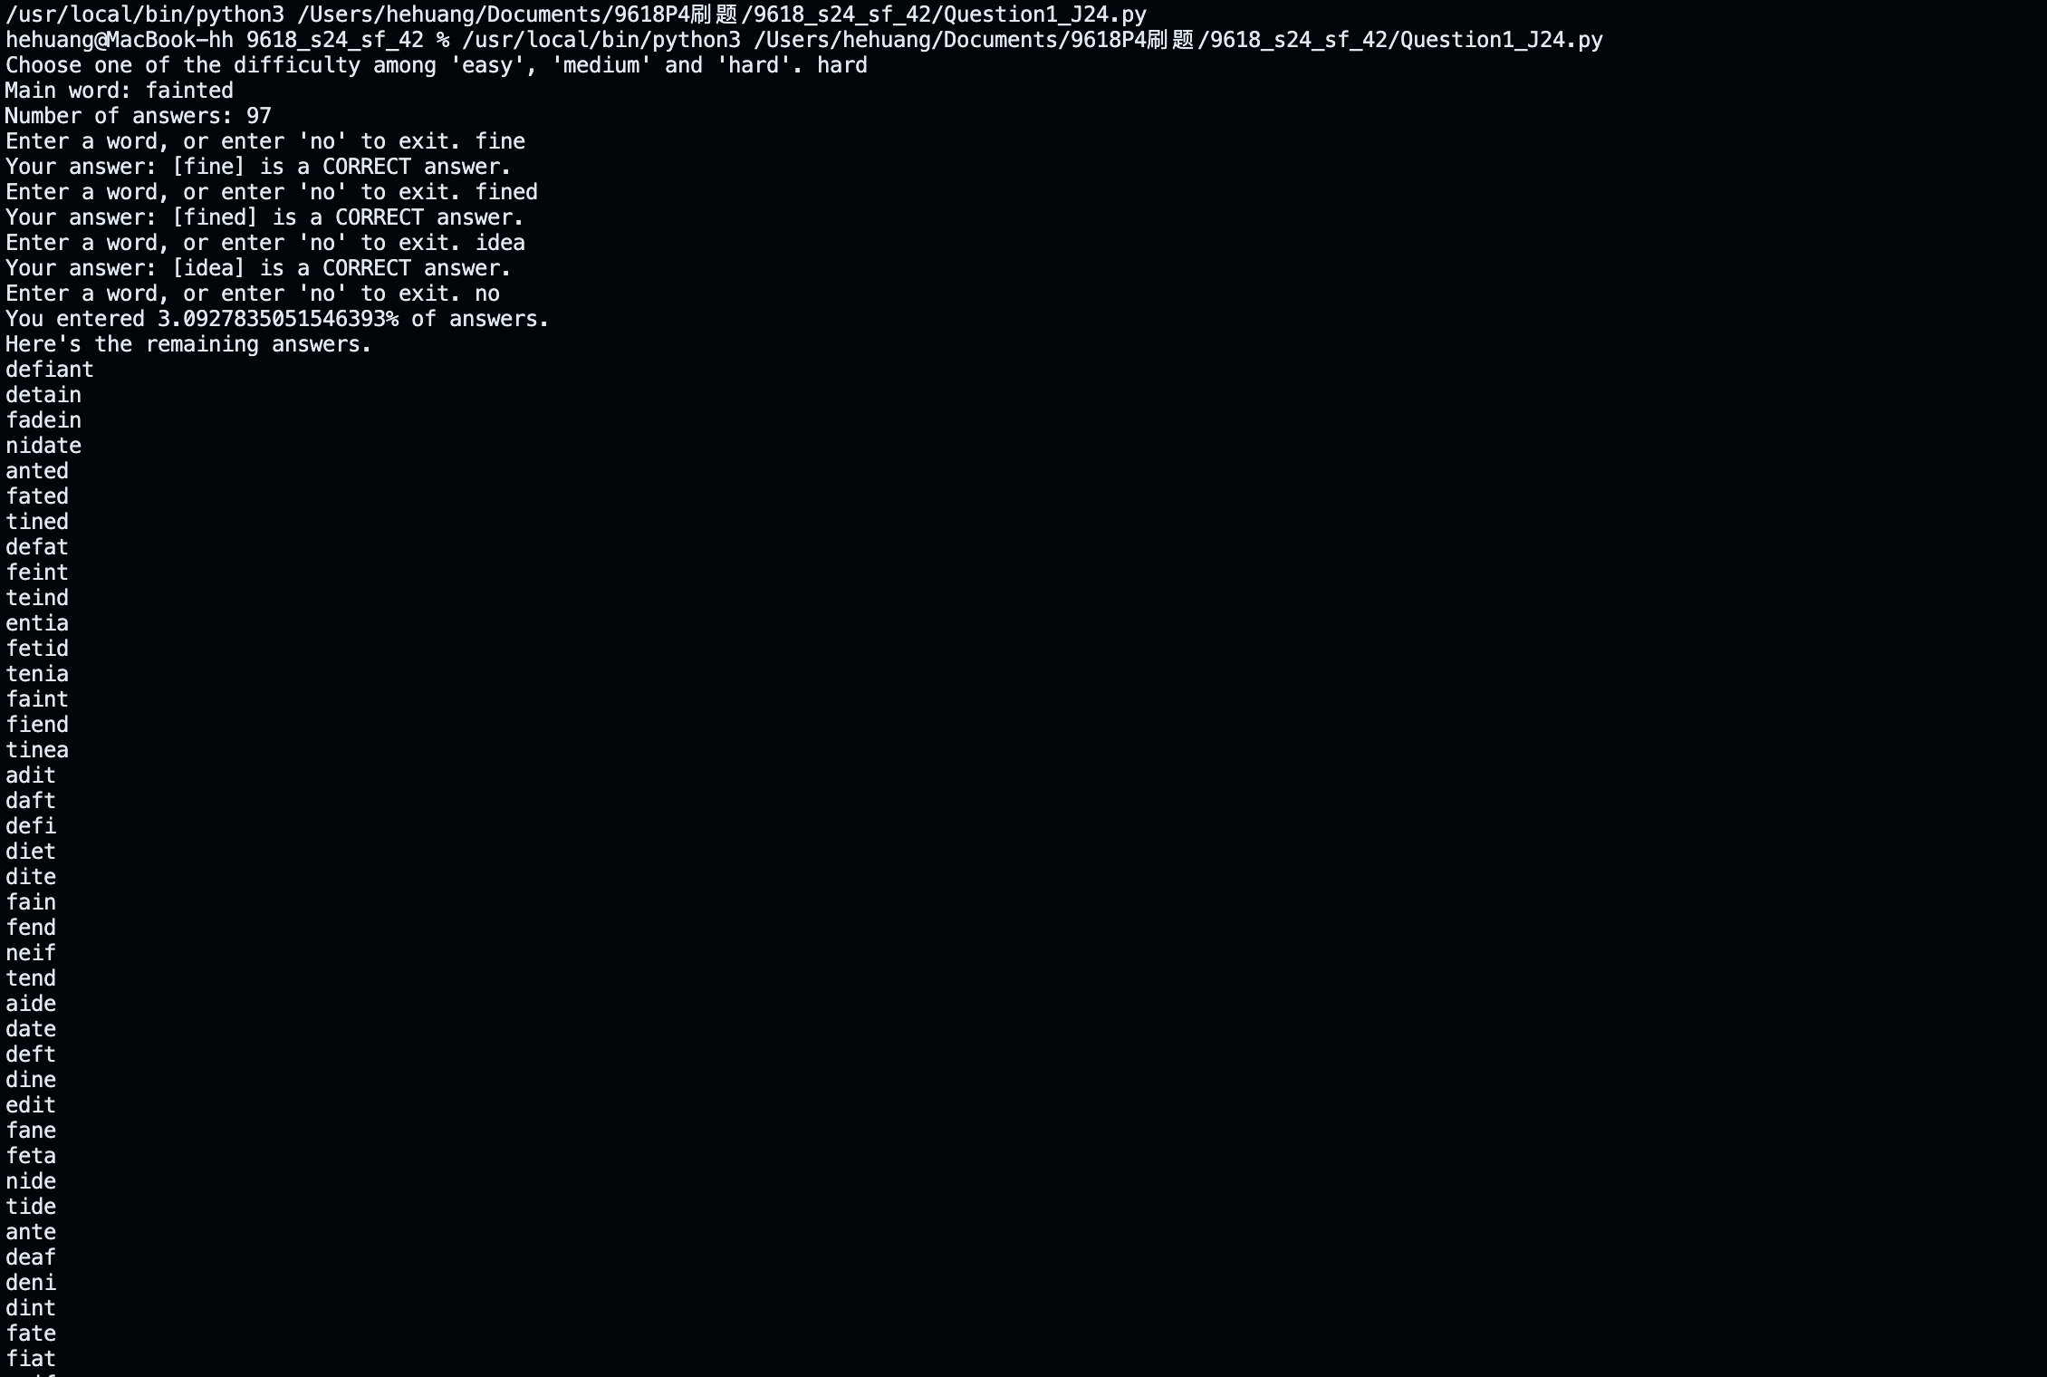
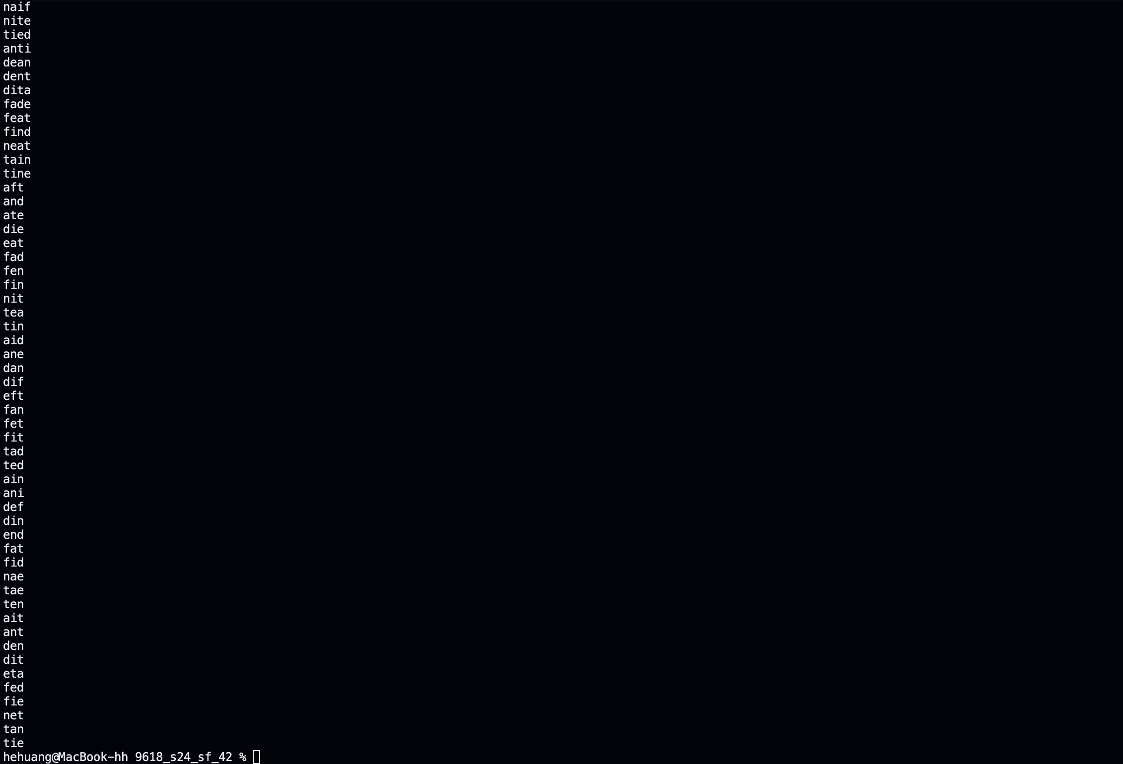

Question 2
Part 2(a)(i)
{Copy and paste program code listing for question 2(a)(i) here}

class Node:
def __init__(self,data):
self.__Data=data # PRIVATE Data: INTEGER
self.__LeftPointer=-1 # PRIVATE LeftPointer: INTEGER
self.__RightPointer=-1 # PRIVATE RightPointer: INTEGER

Part 2(a)(ii)
{Copy and paste program code listing for question 2(a)(ii) here}

class Node:
def __init__(self,data):
self.__Data=data # PRIVATE Data: INTEGER
self.__LeftPointer=-1 # PRIVATE LeftPointer: INTEGER
self.__RightPointer=-1 # PRIVATE RightPointer: INTEGER

def GetLeft(self): return self.__LeftPointer
def GetRight(self): return self.__RightPointer
def GetData(self): return self.__Data

Part 2(a)(iii)
{Copy and paste program code listing for question 2(a)(iii) here}

class Node:
def __init__(self,data):
self.__Data=data # PRIVATE Data: INTEGER
self.__LeftPointer=-1 # PRIVATE LeftPointer: INTEGER
self.__RightPointer=-1 # PRIVATE RightPointer: INTEGER

def GetLeft(self): return self.__LeftPointer
def GetRight(self): return self.__RightPointer
def GetData(self): return self.__Data

def SetLeft(self,num): self.__LeftPointer=num
def SetRight(self,num): self.__RightPointer=num
def SetData(self,num): self.__Data=num

Part 2(b)(i)
{Copy and paste program code listing for question 2(b)(i) here}

class TreeClass:
def __init__(self):
self.__Tree=[Node(-1) for _ in range(19)] # PRIVATE Tree: ARRAY[0:19] OF Node
self.__FirstNode=-1 # PRIVATE FirstNode: INTEGER
self.__NumberNodes=0 # PRIVATE NumberNodes: INTEGER

Part 2(b)(ii)
{Copy and paste program code listing for question 2(b)(ii) here}

class TreeClass:
def __init__(self):
self.__Tree=[Node(-1) for _ in range(19)] # PRIVATE Tree: ARRAY[0:19] OF Node
self.__FirstNode=-1 # PRIVATE FirstNode: INTEGER
self.__NumberNodes=0 # PRIVATE NumberNodes: INTEGER

def InsertTree(self, NewNode):
if self.__NumberNodes==0:
self.__Tree[self.__NumberNodes]=NewNode
self.__NumberNodes+=1
self.__FirstNode=0
else:
self.__Tree[self.__NumberNodes]=NewNode
Current=self.__FirstNode
Found=False
while not Found:
if NewNode.GetData()>self.__Tree[Current].GetData():
if self.__Tree[Current].GetRight() == -1:
self.__Tree[Current].SetRight(self.__NumberNodes)
self.__NumberNodes+=1
Found=True
else:
Current=self.__Tree[Current].GetRight()
else:
if self.__Tree[Current].GetLeft() == -1:
self.__Tree[Current].SetLeft(self.__NumberNodes)
self.__NumberNodes+=1
Found=True
else:
Current=self.__Tree[Current].GetLeft()

Part 2(b)(iii)
{Copy and paste program code listing for question 2(b)(iii) here}

class Node:
def __init__(self,data):
self.__Data=data # PRIVATE Data: INTEGER
self.__LeftPointer=-1 # PRIVATE LeftPointer: INTEGER
self.__RightPointer=-1 # PRIVATE RightPointer: INTEGER

def GetLeft(self): return self.__LeftPointer
def GetRight(self): return self.__RightPointer
def GetData(self): return self.__Data

def SetLeft(self,num): self.__LeftPointer=num
def SetRight(self,num): self.__RightPointer=num
def SetData(self,num): self.__Data=num

class TreeClass:
def __init__(self):
self.__Tree=[Node(-1) for _ in range(19)] # PRIVATE Tree: ARRAY[0:19] OF Node
self.__FirstNode=-1 # PRIVATE FirstNode: INTEGER
self.__NumberNodes=0 # PRIVATE NumberNodes: INTEGER

def InsertTree(self, NewNode):
if self.__NumberNodes==0:
self.__Tree[self.__NumberNodes]=NewNode
self.__NumberNodes+=1
self.__FirstNode=0
else:
self.__Tree[self.__NumberNodes]=NewNode
Current=self.__FirstNode
Found=False
while not Found:
if NewNode.GetData()>self.__Tree[Current].GetData():
if self.__Tree[Current].GetRight() == -1:
self.__Tree[Current].SetRight(self.__NumberNodes)
self.__NumberNodes+=1
Found=True
else:
Current=self.__Tree[Current].GetRight()
else:
if self.__Tree[Current].GetLeft() == -1:
self.__Tree[Current].SetLeft(self.__NumberNodes)
self.__NumberNodes+=1
Found=True
else:
Current=self.__Tree[Current].GetLeft()

def OutputTree(self):
if self.__NumberNodes==0:
print("No nodes.")
else:
for i in range(self.__NumberNodes):
print(f"{self.__Tree[i].GetLeft()} {self.__Tree[i].GetData()} {self.__Tree[i].GetRight()}")

Part 2(c)(i)
{Copy and paste program code listing for question 2(c)(i) here}
#main
TheTree=TreeClass()

Part 2(c)(ii)
{Copy and paste program code listing for question 2(c)(ii) here}

#main
TheTree=TreeClass()
TheTree.InsertTree(Node(10))
TheTree.InsertTree(Node(11))
TheTree.InsertTree(Node(5))
TheTree.InsertTree(Node(1))
TheTree.InsertTree(Node(20))
TheTree.InsertTree(Node(7))
TheTree.InsertTree(Node(15))
TheTree.OutputTree()

Part 2(c)(iii)
{Copy and paste screenshot for question 2(c)(iii) here}
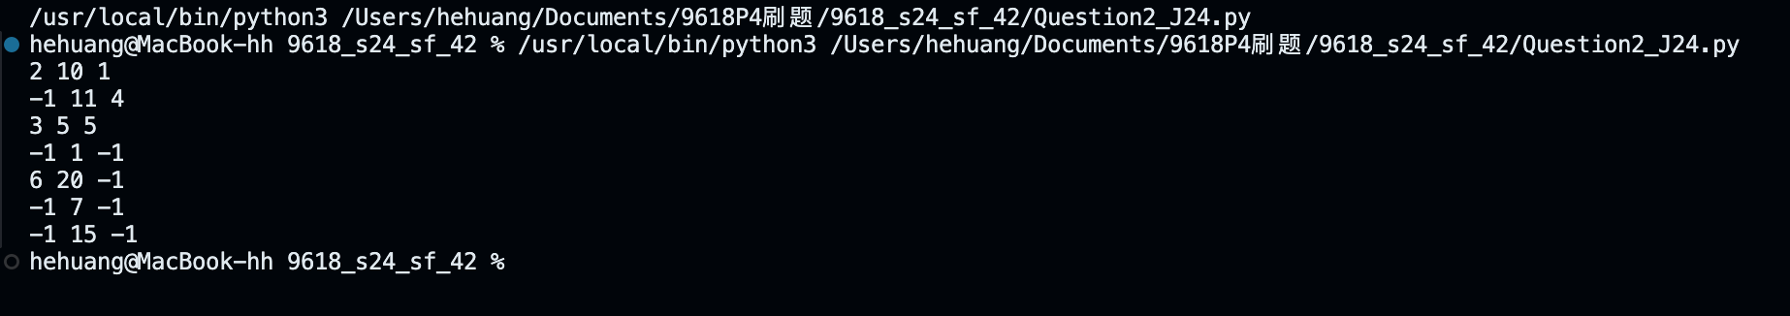

Question 3
Part 3(a)
{Copy and paste program code listing for question 3(a) here}

#main
NumberArray=[100,85,644,22,15,8,1]

Part 3(b)(i)
{Copy and paste program code listing for question 3(b)(i) here}

def RecursiveInsertion(IntegerArray,NumberElements):
if NumberElements<=1:
return IntegerArray
else:
RecursiveInsertion(IntegerArray,NumberElements-1)
LastItem=IntegerArray[NumberElements-1]
CheckItem=NumberElements-2
LoopAgain=True
if CheckItem<0:
LoopAgain=False
elif IntegerArray[CheckItem]<LastItem:
LoopAgain=False
while LoopAgain:
IntegerArray[CheckItem+1]=IntegerArray[CheckItem]
CheckItem-=1
if CheckItem<0:
LoopAgain=False
elif IntegerArray[CheckItem]<LastItem:
LoopAgain=False

IntegerArray[CheckItem+1]=LastItem
return IntegerArray

Part 3(b)(ii)
{Copy and paste program code listing for question 3(b)(ii) here}

#main
NumberArray=[100,85,644,22,15,8,1]

SortedArray=RecursiveInsertion(NumberArray, len(NumberArray))
print("Recursive")
print(SortedArray)

Part 3(b)(iii)
{Copy and paste screenshot for question 3(b)(iii) here}

Part 3(c)(i)
{Copy and paste program code listing for question 3(c)(i) here}

def IterativeInsertion(IntegerArray,NumberElements):

for i in range(NumberElements):
HolePosition=i
Num=IntegerArray[i]
while HolePosition>0 and IntegerArray[HolePosition-1] > Num:
IntegerArray[HolePosition]=IntegerArray[HolePosition-1]
HolePosition-=1
Num=IntegerArray[HolePosition]

Part 3(c)(ii)
{Copy and paste program code listing for question 3(c)(ii) here}

#main
NumberArray=[100,85,644,22,15,8,1]

SortedArray=RecursiveInsertion(NumberArray, len(NumberArray))
print("Recursive")
print(SortedArray)

IterativeSortedArray=RecursiveInsertion(NumberArray, len(NumberArray))
print("Iterative")
print(IterativeSortedArray)

Part 3(c)(iii)
{Copy and paste screenshot for question 3(c)(iii) here}

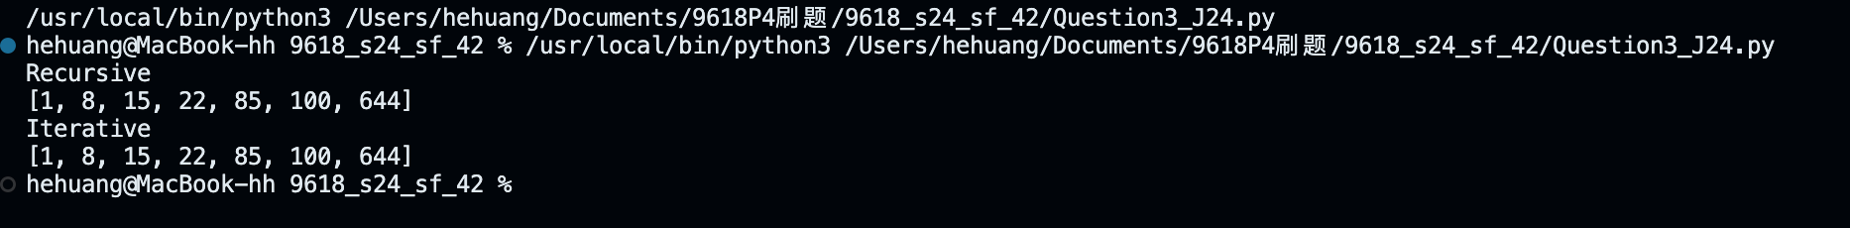

Part 3(d)(i)
{Copy and paste program code listing for question 3(d)(i) here}

def BinarySearch(IntegerArray,First,Last,ToFind):
if First>Last:
return -1

Mid=(First+Last)//2
if IntegerArray[Mid]==ToFind:
return Mid
elif IntegerArray[Mid]>ToFind:
return BinarySearch(IntegerArray,First,Mid-1,ToFind)
elif IntegerArray[Mid]<ToFind:
return BinarySearch(IntegerArray,Mid+1,Last,ToFind)

Part 3(d)(ii)
{Copy and paste program code listing for question 3(d)(ii) here}

#main
NumberArray=[100,85,644,22,15,8,1]

SortedArray=RecursiveInsertion(NumberArray, len(NumberArray))
print("Recursive")
print(SortedArray)

IterativeSortedArray=RecursiveInsertion(NumberArray, len(NumberArray))
print("Iterative")
print(IterativeSortedArray)

Location=BinarySearch(IterativeSortedArray,0,len(IterativeSortedArray)-1,644)
if Location == -1: print("Not found")
else: print(Location)

Part 3(d)(iii)
{Copy and paste screenshot for question 3(d)(iii) here}
